**1.3 Healthcare Data resources and UK BioBank**

Angela Wood and Fergus Imrie

[amw79@medschl.cam.ac.uk](mailto:amw79@medschl.cam.ac.uk)

**Aims**

* Overview of major healthcare data resources
  + UK Biobank
  + Emerging Risk Factors Collaboration
  + NHS Digital Trusted Research Environment
  + INTERVAL
* Considerations and challenges in handling healthcare data resources
* Inspire new research ideas

**Objectives**

* Challenges of healthcare dataset (UK Biobank)
* Individual participant data meta-analysis (Emerging risk factors collaboration)
* Population-wide Electronic Health records (NHS Digital Trusted Research Environment)
* Large-scale multi-omics (INTERVAL)

**Challenges of healthcare dataset**

* Healthcare data from different sources;
  + Imaging
  + Text
  + Tabular (including omcis and patient health history)
  + Temporal….
* Source of such data: can impact the data and usability
  + EHR
  + Biobanks
  + Clinical trials
  + Medical studies
* UK BioBank
  + <https://www.ukbiobank.ac.uk/>
  + Over 0.5 mil volunteers in UK, 40 to 69 yo
  + Enrollment between 2006 to 2010
    - Invitation-based
  + Follow-up of up to 30 years after enrollment
  + Information from Biobanks: Heterogeneity of information
    - Questionnaires
      * Lifestyle, physical activity, habits, diet and social/professional status
      * **Test of memory** (source of reporting bias) –Text
    - Interview
      * Clinical history questions (diagnosis, symptoms, and tests)
      * Conducted by nurses (source of reporting bias)
    - Physical Measurement
      * Body composition, visual and auditory acuity, bp, heigh, weight etc.
      * imaging
    - Basic screenings/ tests
      * FEV, FVC, ultrasound bone densitometry
    - Fitness test
      * ECG — waveforms
    - Samples
      * Blood cell counts, blood and urine composition, DNA information
      * Omics test undertaken – Genetics
  + Features can be broadly categorized into:
    - Demographics – questionnaire
    - Physical measurements and body compositions – physical measurements
    - Clinical history – questionnaire, nurse interview
    - Symptoms
    - Diagnostic tests and biomarkers – Basic screening/tests, fitness test, samples
    - Physical activity - fitness test
    - Psychology - questionnaire
    - Diet and nutrition - questionnaire
    - Social and environment - questionnaire
  + Data collection
    - 22 Assessment centers
    - Allowing regional variation
      * Problem with harmonizing across regions
      * Problems with equipment and methods
    - Enrolled over four years between 2006 to 2010
      * Time: source of differences between samples
* Medical dataset vs ML datasets

| **Medical datasets** | **ML datasets** |
| --- | --- |
| Example: BreCaHAD  <https://bmcresnotes.biomedcentral.com/articles/10.1186/s13104-019-4121-7> | Example: ImageNet  <https://www.image-net.org/> |
| Often relatively small | Can be very large |
| Dirty: different conditions, missing data, missing outcomes etc. | Clean |
| Multimodal (heterogenous) | Unimodal |
| Broad range of purposes:  Make discoveries, test hypothesis, insurance  “If we could do something”  Render the results to be flawed/ impossible/ meaningless | To test algorithms  = often have performed preliminary evaluations |

* Unique challenges in healthcare data
  + Multiple streams of measurement
  + Sparse, irregularly, and informatively sampled measurements
  + Multiple outcomes of interest
    - Various events of interests
    - Various morbidities (i.e. not just cats vs dogs)
  + True clinical states are sometime unobserved (e.g. onset of disease)
  + Many possible patterns (heterogenous phenotypes, comorbidities)
* Accessing healthcare data
  + Strict regulations due to valid concerns regarding privacy
  + Strong regulators (e.g. HIPAA and GDPR) not allowing direct share private data to ML community from data holders (e.g. hospitals)

**Assessing cardiovascular risk using multiple studies: The Emerging Risk Factors Collaboration**

* Motivation
  + Enhance precision/ reduce overfitting/ increase generalizability
* Challenges
  + Harmonization of information
  + Combining analysis of different study designs
  + Accounting for measurement errors
  + Adjusting for known or potential confounders observed in a subset of studies
  + Assessing effect modification (within or between studies)
  + Dealing with missing data
* Emerging risk factors collaboration (ERFC)
  + <https://www.phpc.cam.ac.uk/ceu/erfc/>
  + Consortium of > 130 prospective studies from 30 countries
    - The Emerging Risk Factors Collaboration: analysis of individual data on lipid, inflammatory and other markers in over 1.1 million participants in 104 prospective studies of cardiovascular diseases
    - <https://link.springer.com/article/10.1007/s10654-007-9165-7>
  + Collated and harmonized individual-participant data (IPD) from ~2.5M participants
  + Aim: to study risk factors for cardiovascular disease and cause-specific mortality in greater detail:
    - Circulating lipid markers
      * Major lipids, apolipoproteins, and risk of vascular disease. JAMA, 2009
        + <https://jamanetwork.com/journals/jama/fullarticle/184863>
      * Lipoprotein(a) concentration and the risk of coronary heart disease, stroke, and nonvascular mortality. JAMA, 2009
        + <https://jamanetwork.com/journals/jama/article-abstract/184315>
      * Lipoprotein-associated phospholipase A(2) and risk of coronary disease, stroke, and mortality: collaborative analysis of 32 prospective studies. Lancet, 2010
        + <https://www.thelancet.com/journals/lancet/article/PIIS0140-6736(10)60319-4/fulltext>
      * Lipid-related markers and cardiovascualar disease prediction. JAMA 2012
        + <https://jamanetwork.com/journals/jama/fullarticle/1187927>
    - Inflammatory markers
      * C-reactive protein concentration and risk of coronary heart disease, stroke, and mortality: an individual participant meta-analysis. Lancet, 2010
        + <https://www.thelancet.com/journals/lancet/article/PIIS0140-6736(09)61717-7/fulltext>
      * Interleukin-6 receptor pathways in coronary disease: a collaborative meta-analysis of 82 studies. Lancet 2012
        + <https://www.thelancet.com/journals/lancet/article/PIIS0140-6736(11)61931-4/fulltext>
      * C-reactive protein, fibrinogen, and cardiovascular disease prediction. N Engl J Med 2012
        + <https://www.nejm.org/doi/full/10.1056/nejmoa1107477>
    - Glycaemia markers
      * Surveillance intervals for small abdominal aortic aneurysms: a meta-anaylsis. JAMA. 2013
        + <https://jamanetwork.com/journals/jama/fullarticle/1656254>
    - Adiposity markers
      * Adult height and the risk of cause-specific death and vascular morbidity in 1 million people: individual participant meta-analysis. Int J Epidemiol 2012
        + <https://www.ncbi.nlm.nih.gov/pmc/articles/PMC3465767/>
      * Global, regional, and national prevalence of overweight and obesity in children and adults during 1980–2013: a systematic analysis for the Global Burden of Disease Study 2013. The Lancet. 2014
        + <https://www.thelancet.com/journals/lancet/article/PIIS0140-6736(14)60460-8/fulltext>
    - Diabetes
      * Leucocyte Telomere Length and Risk of Type 2 Diabetes Mellitus: New Prospective Cohort Study and Literature-Based Meta-Analysis. Lustig AJ, editor. PLoS ONE
        + <https://journals.plos.org/plosone/article?id=10.1371/journal.pone.0112483>
    - Cardiometabolic multimorbidity
      * Association of cardiometabolic multimorbidity with mortality. JAMA. 2015
        + <https://jamanetwork.com/journals/jama/fullarticle/2382980>
    - Alcohol
      * Risk thresholds for alcohol consumption: combined analysis of individual-participant data for 599 912 current drinkers in 83 prospective studies
        + <https://www.thelancet.com/journals/lancet/article/PIIS0140-6736(18)30134-X/fulltext>
    - Depression
      * Association between depressive symptoms and incident cardiovascular diseases. JAMA. 2020
        + <https://jamanetwork.com/journals/jama/fullarticle/2774050#:~:text=In%20a%20pooled%20analysis%20of%20563%20255%20participants%20in%2022,magnitude%20of%20associations%20was%20modest>.
  + Aetiological hypothesis and risk prediction assessment
  + Methodological developments occurring in parallel as necessary
* Exemplar: Risk thresholds for alcohol consumption
  + Rationale:
    - Low-risk limits recommended for alcohol consumption vary substantially across different national guidelines
  + Aim:
    - To define thresholds associated with lowest risk for all-cause mortality and

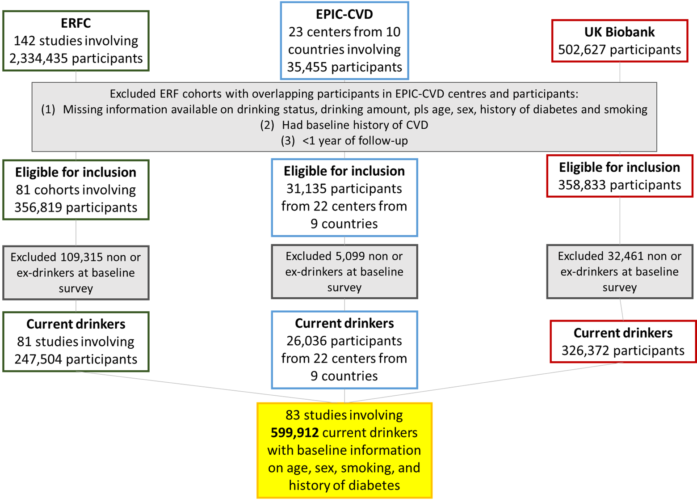

* + No overlapping participants across the three groups
  + No missing data
  + People with no existing CVD
* Harmonization of information across studies
  + Months taken to harmonizing
  + Checking with study coordinators for agreement

| **Methods to record alcohol consumption** | **Different types of alcohol** | **Various recoding formats** |
| --- | --- | --- |
| Self-administered  Interview-led questionnaires  Food frequency questionnaires  Dietary recall surveys | Beer, wine, cider, spirits/liquor, alcopops, long drink, fortified wine, liqueur, sake, shochu, tharra, aperitif/digestif | Amount in a given period  Frequency of drinks in a given period  Categories for amount of frequency |
| ↓ | | |
| Harmonised and cross-referenced into the following variables:  Amount, status, duration, stop age, start age, years stopped, usage frequency and  Categorised as “never”, “never/ex”, “ex”, “ex/current”, and “current” drinkers | | |
| ↓ | | |
| UK standard scale of grams/ week  (1 unit = 8 grams of ethanol) | | |

* ERFC covering the highest recruitment amongst ERFC, EPIC-CVD, UK Biobank:
* Consumption divided into 4 categories:
  + Between 7 to 10% include those drinking more than recommended
  + Majority drinking within guidelines
* Smokers
* UK biobank more healthy than others
* Individual participant data meta-analysis strategy
  + Prospective studies: cohort (78)/ nested case-control (4)/ case-cohort(1)

| **2-Stage analysis strategy** |
| --- |
| Stage 1: Estimate study-specific risk ratios  Cox model/ (un)conditional logistic model/ Prentice-Weighted Cox model  Stratified by sex, centre  Adjusted for age, smoking and diabetes |
| ↓ |
| Stage 2: Pool estimates by random-effects meta-analysis |

* Accounting for measurement error in reported drinking
  + Publications of:
    - **Measurement error as an explanation for the alcohol harm paradox: analysis of eight cohort studies**
      * <https://academic.oup.com/ije/article/49/6/1836/5913111?login=false>
    - AJE 2013 (?)
  + Measurement error/ within-person variability in exposure/confounders
    - Biased associations in analysis using only single measurements
    - Often quantified by regression dilution ratio (RDR)
  + To correct bias, we estimated long-term “usual” alcohol consumption
    - Multi-level regression calibration
    - 152,640 serial assessments in 71,011 individuals from 37 studies
    - Regress re-survey measures (or lifetime alcohol consumption available in EPIC-CVD) on baseline alcohol consumption, adjusted for relevant covariates with random effects for study and re-survey
    - Estimate conditional expectations of usual levels and include in regression models
* Study and re-survey regression dilution ratios
  + Average regression dilution ratio around 0.54
  + Enhanced precision to assess less common outcomes
* Key points
  + Described:
    - Challenges arising from disparate study designs
    - Data available for enhanced precision
    - Handling measurement error using repeated measures in sub-samples
    - Computational limitations individual participant data meta-analysis with large datasets
    - Translation of findings in to clinically useful interpretations
  + Stat program:
    - http://www.phpc.cam.ac.uk/ceu/erfc/programs//

**Part 3: Population-wide Electronic Health Records Exemplar: NHS Digital Trusted Research Environment**

* BHF data science centre:
  + Interrogating linked health data from >60 million people to better understand CVD
  + <https://www.hdruk.ac.uk/helping-with-health-data/bhf-data-science-centre/>
* UK-wide network of national Trusted Research Environment (TREs)

[Diagram]

* NHS Digital’s new Trusted Research Environment
  + **Linked electronic health records for research on a nationwide cohort of more than 54 million people in England: data resource**
  + <https://www.bmj.com/content/373/bmj.n826>

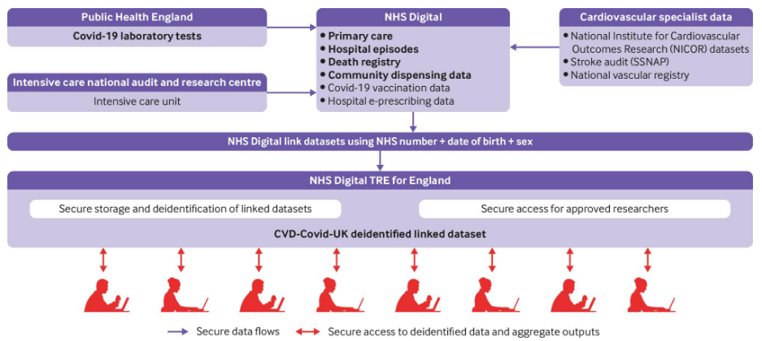

* Enables whole population research:
  + >55 million people alive on 1st Jan 2020 -> >95% of population
  + Statistically powerful
  + Comprehensive information on characteristics and health outcomes
  + Includes all age groups, ethnicities, geographic locations, socioeconomic, health and personal characteristics
  + All datasets updated monthly
* CVD-COVID-UK/COVID-IMPACT consortium: enabling across to UK population linked health data
  + <https://www.hdruk.ac.uk/projects/cvd-covid-uk-project/>
  + [bhfdsc@hdruk.ac.uk](mailto:bhfdsc@hdruk.ac.uk)
  + Population coverage:
    - England (NHSD): >55M
    - Scotland (Safe Haven): >5M
    - Wales (SAIL): >3M
  + Consortium
    - >250 members
    - >40 NHS and academic organisations
  + Analysts:
    - >70 analysts in the TREs
    - TRE(s) accessible by approved researchers
  + Project:
    - 30+ approved projects, more coming
    - Protocols/ algorithms in GitHub
    - Published outputs…
* CVD-COVID-UWCOVID-IMPACT projects:
  + Methods
    - Data management and analysis methods
    - High-throughput phenotyping approaches
    - Improving methods to minimise bias in ethnicity data
  + Medicines
    - Effects of ACE inhibitors & ARBs on COVID-19
    - Impact of COVID-19 on managing BP and lipids
    - Assessing COVID-19 impact through medicines
    - Antipsychotic prescribing during the pandemic and
    - cardiovascular risk in patients with dementia
    - Evaluation of antithrombotic use on COVID-19 outcomes
    - Repurposing medicines to prevent COVID-19
  + Others
    - COVID-19 infection, vaccination and vascular risk
    - Direct and indirect effects of COVID-19 in people with
    - cardiovascular disease
    - COVID and cardiovascular disease risk prediction
    - Impact of COVID-19 on Congenital Heart Disease (CHD)
    - patients undergoing cardiac surgery
    - Influence of multi-morbidity on outcomes of COVID-19
    - Predicting severe COVID-19 in people with rare diseases Genomics of multi-morbidity and susceptibility to COVID-19
    - Longer-term effects of COVID-19 in non-hospitalised people
    - Evaluating how palliative and end of life care teams have responded to COVID-19
    - Coronary revascularisation and outcomes before and after the COVID-19 pandemic
    - Children admitted to hospital with COVID-19 — risk factors, risk groups and NHS care utilization
    - Understanding the increased risk of severe COVID-19 in people with intellectual & developmental disabilities
    - Risks of cardiovascular disease in people with COVID-19 and pre-existing respiratory disease
    - Impact of COVID-19 on eye disease
    - Impact of COVID-19 on heart failure
    - Impact of COVID-19 on people with diabetes
* Novel and key benefits of population-wide data for research:
  + Scale and depth
  + Generalisability
  + Public health policies
* Challenges of using population-wide data for research
  + ~65 million people alive on 1st Jan 2020, registered with an NHS general practitioners in England, Scotland and Wales
  + Consistent data curation pipelines and quality checks
  + Defining population of interest
  + Phenotyping diseases and conditions
  + Study designs
  + Analytical approaches and interpretation
  + Distributing analytical pipelines between systems
  + Computationally efficient analyses
  + Open access Protocols/algorithms in GitHub
* Linking data from different healthcare settings to ascertain incident cardiovascular events
  + <https://www.bmj.com/content/373/bmj.n826>

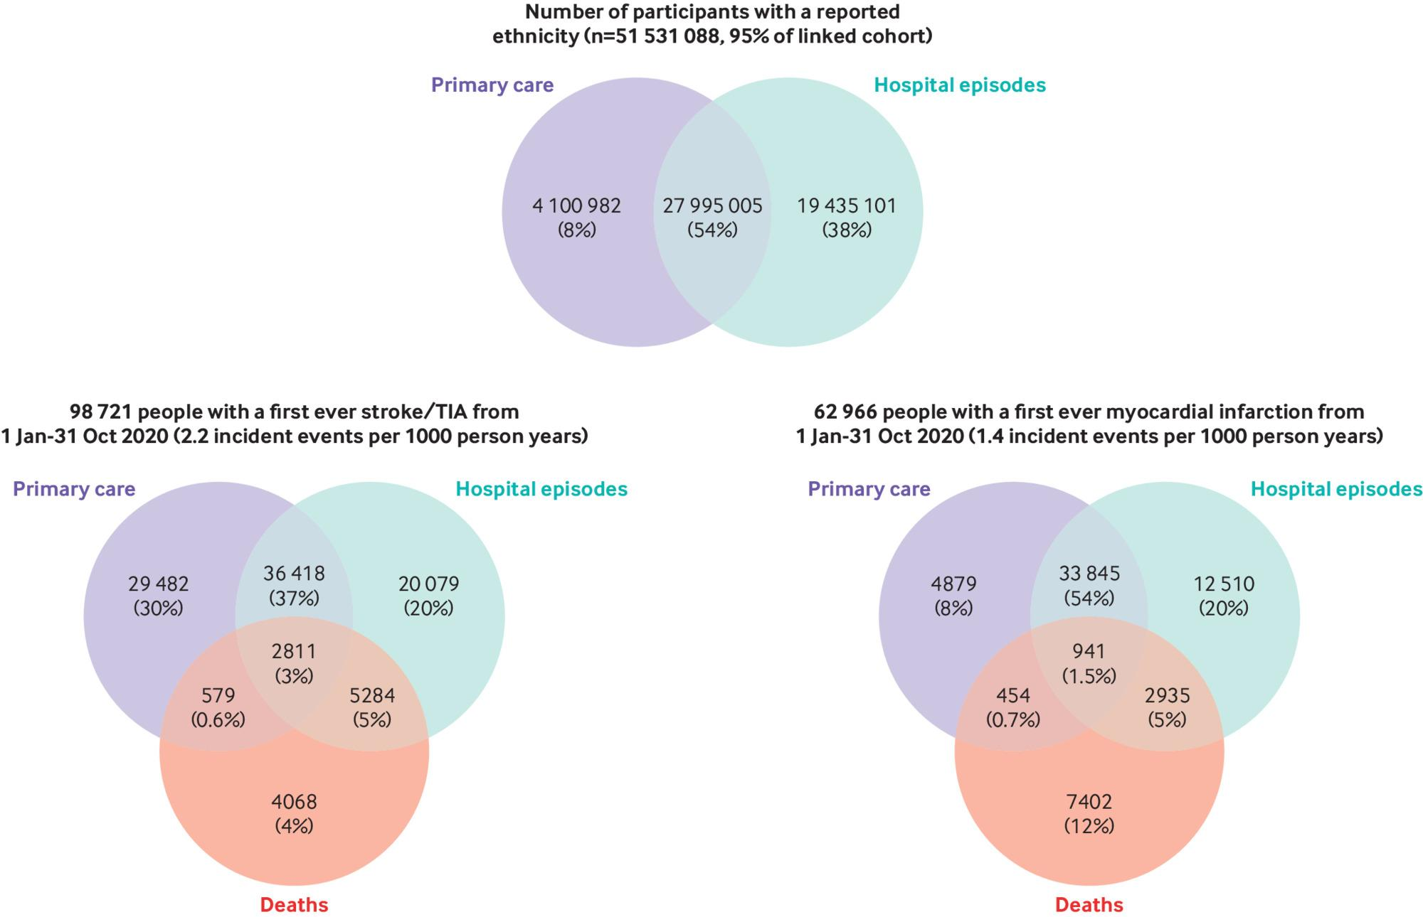

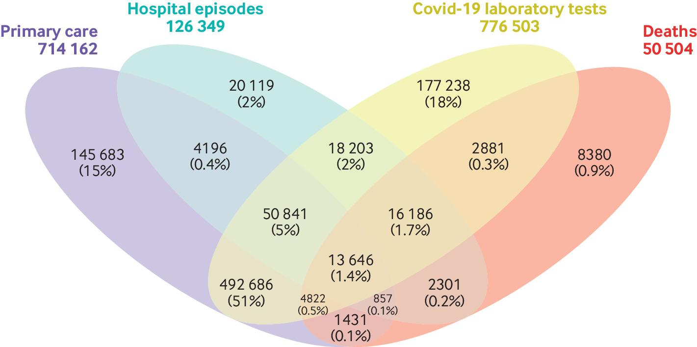

* + 3.5 million people with COVID-19 by mid Feb 2021:
    - 3.1 million with a positive test
    - 2.4 million diagnosed in primary care
    - 364,000 hospitalized
* Higher risks of major vascular and arterial disease following hospitalised COVID-19
  + Non-hospitalised also remain higher risk (double) of vascular events of up to 2 years
  + Knight et al., 2022 Circulation (?)
* Key points:
  + During the COVID-19 pandemic, it has become possible to conduct research of clinical and policy relevance at UK population-wide scale using rich, diverse linked national health data
  + A critical enabler has been the establishment in 2020-21 of NHS Digital's new trusted research environment for England
  + This has enabled many, well-powered studies and insights
  + All analyses require essential data curation/wrangling tasks (at least 80% of research project time)
  + Transparency in all stages of analyses — reproducible research
  + National coordination, a team science approach and public support essential
  + Hot press: CODE-EHR best practice framework for the use of structured electronic healthcare records in clinical research, BMJ 2022

**Part 4: Large-scale multi-omics: Exemplar “INTERVAL”**

* INTERVAL trial:
  + <https://www.intervalstudy.org.uk/>
  + Randomized trial assessing how often blood donors can safely give whole blood
  + In addition to questions that can be answered by the randomised trial, created a bioresource of 50,000 trial participants to address other epidemiological questions, particularly those relating to genetics
* Domains of the expressed genome: study at scale with Interval bioresource:
  + <https://www.phpc.cam.ac.uk/ceu/interval-bioresource/>
  + All 50,000 participants:
    - Basic lifestyle and self-reported health information using web-based questionnaire

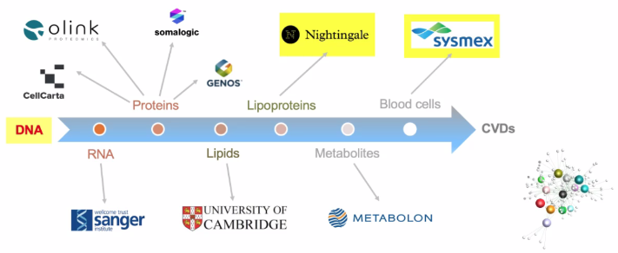

**Example of studies from INTERVAL:**

* The allelic landscape of human blood cell trait variation and links to complex disease. Cell 2016
  + <https://www.cell.com/cell/fulltext/S0092-8674(16)31463-5?_returnURL=https%3A%2F%2Flinkinghub.elsevier.com%2Fretrieve%2Fpii%2FS0092867416314635%3Fshowall%3Dtrue>
  + Astle et al.
* Genomic atlas of the human plasma proteome. Nature 2018
  + <https://www.nature.com/articles/s41586-018-0175-2>
  + Sun et al.
* Genomic and drug target evaluation of 90 cardiovascular proteins in 30,931 individuals. Nature Metabolism 2020
  + <https://www.nature.com/articles/s42255-020-00287-2>
  + Folkersen et al.
* Whole-exome sequencing identifies rare genetic variants associated with human plasma metabolites. AJHG 2022
  + <https://www.cell.com/ajhg/fulltext/S0002-9297(22)00157-4>
  + Bomba et al.
* Machine learning optimized polygenic scores for blood cell traits identify sex-specific trajectories and genetic correlations with disease. Cell Genomics 2022
  + <https://www.cell.com/cell-genomics/pdf/S2666-979X(21)00107-5.pdf>
  + Xu et al.

**Final remarks:**

* Large-scale data resources more widely available and accessible
  + With restrictions
* Unique challenges:
  + Esp. from routine health data (those not collected for research)
* Data generally need to be pre-processing steps and data quality checks
  + Project specific
* Get in touch:
  + amw79@medschl.cam.ac.uk